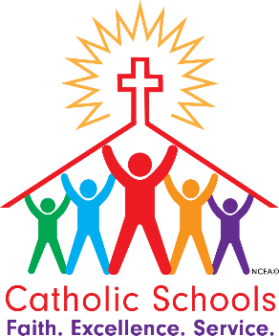

Catholic Schools Week
January 29th thru February 3rd
Theme: Catholic Schools: Faith, Excellence, Service

Monday, January 30th
Celebrating Our Community
Service Day
January, all school service project for the month
Diaper Distribution for Prepares
Students that attended Mass this weekend in uniform get Free Dress on Monday

Tuesday, January 31st
Celebrating Our Students
Student Day
Peace Day-
Students may wear the blue SMM Peace Day shirts OR their regular uniform

Wednesday, February 1st
Celebrating Our Parish
Faith filled Catholic Day
School Mass at 8:30 a.m.

Thursday, February 2nd
Celebrating Our Volunteers and Alumni
Volunteer and Alumni Appreciation Day
Distinguished Graduate, Jennifer (Thorp) Keeney
Catholic Schools Week Prayer Service and Distinguished Graduate Celebration at 2:00

Friday, February 3rd
Celebrating Our Nation
Multicultural Day
First Friday St. Vincent de Paul Food Drive- canned fruit requested

